**Create an employee table ‘EMP’ with following fields**

|  |  |
| --- | --- |
| **Name** | **Type** |
| EMPNO | NUMBER |
| ENAME | VARCHAR2(20) |
| JOB | VARCHAR2(20) |
| SALARY | NUMBER(10,2) |
| COMMISSION | NUMBER(7,2) |
| DEPTNO | NUMBER |

SQL> create table EMP(empno number primary key,ename varchar2(20),job varchar2(20),salary number(10,2),commission number(7,2),deptno number);

Table created.

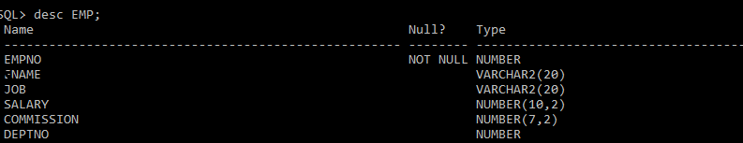

1. **Insert records into the table**

SQL> insert into EMP values(&empno,'&ename','&job',&salary,&commission,&deptno);

Enter value for empno: 101

Enter value for ename: ajo

Enter value for job: analyst

Enter value for salary: 25000

Enter value for commission: 2000

Enter value for deptno: 159

old 1: insert into EMP values(&empno,'&ename','&job',&salary,&commission,&deptno)

new 1: insert into EMP values(101,'ajo','analyst',25000,2000,159)

1 row created.

SQL> /

Enter value for empno: 102

Enter value for ename: ajay

Enter value for job: NULL

Enter value for salary: 15000

Enter value for commission: 1000

Enter value for deptno: 753

old 1: insert into EMP values(&empno,'&ename','&job',&salary,&commission,&deptno)

new 1: insert into EMP values(102,'ajay','NULL',15000,1000,753)

1 row created.

SQL> /

Enter value for empno: 103

Enter value for ename: anathan

Enter value for job: manager

Enter value for salary: 30000

Enter value for commission: 3500

Enter value for deptno: 321

old 1: insert into EMP values(&empno,'&ename','&job',&salary,&commission,&deptno)

new 1: insert into EMP values(103,'anathan','manager',30000,3500,321)

1 row created.

SQL> /

Enter value for empno: 104

Enter value for ename: akshay

Enter value for job: clerk

Enter value for salary: 15000

Enter value for commission: 1000

Enter value for deptno: 147

old 1: insert into EMP values(&empno,'&ename','&job',&salary,&commission,&deptno)

new 1: insert into EMP values(104,'akshay','clerk',15000,1000,147)

1 row created.

SQL> /

Enter value for empno: 105

Enter value for ename: akshara

Enter value for job: manager

Enter value for salary: 25000

Enter value for commission: 3000

Enter value for deptno: 258

old 1: insert into EMP values(&empno,'&ename','&job',&salary,&commission,&deptno)

new 1: insert into EMP values(105,'akshara','manager',25000,3000,258)

1 row created.

1. **Display all the records.**

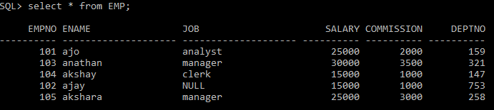

1. **Insert job as ‘Clerk’ for all ‘NULL’ job types.**

SQL> update EMP set job='Clerk' where job='NULL';

1 row updated.

1. **Change the job type ‘Analyst’ to ‘Data Analyst’**

SQL> update EMP set job='Data analyst' where job='analyst';

1 row updated.

1. **Add a new field ‘DOJ’ to table and insert the date 17-Dec-2020 to all records**

SQL> alter table EMP add(DOJ DATE);

Table altered.

SQL> update EMP set DOJ='17-DEC-2020';

5 rows updated.

1. **Display all distinct job type**



1. **Display name of all employees in department 159 and 147.**



1. **Find the total salary of all employees**



1. **List name and total salary i.e. salary + commission.**

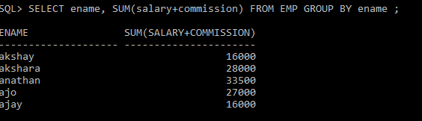

1. **Delete column commission and update salary as salary + commission.**

SQL> update EMP set salary=salary+commission;

5 rows updated.

SQL> alter table EMP drop(commission);

Table altered.

1. **Display the employee with salary**



1. **Change column name ename to empname**

SQL> alter table EMP rename column ename to empname;

Table altered.

1. **Rename the EMP to employee1**

SQL> alter table EMP rename to EMPLOYEE1;

Table altered.